Daily Class Schedule 2017-2018
Caterpillars | Butterflies | Ladybugs | Sunflowers
6:30-8:00 Arrivals  8:00-9:00 Outside play  9:00-9:15 Diapers/Wash up  9:15-9:30 AM Snack  9:30-10:00 Free Play  10:00-10:30 Circle Time  10:30-10:50 Art and Activities  10:50-11:00 Diapers/Wash Up  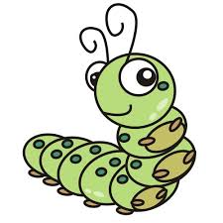  11:00-11:30 Lunch  11:30-11:50 Outdoor Play  11:50-12:15 Wash up/Diapers  12:15-2:30 Napping  2:30-3:15 Teacher Directed Activities  3:15-3:30 Diaper/ Wash Up  3:30-3:45 PM Snack  3:45-4:15 Child Directed Play  4:15-6:00 Outdoor Combined Play/Pick Ups | 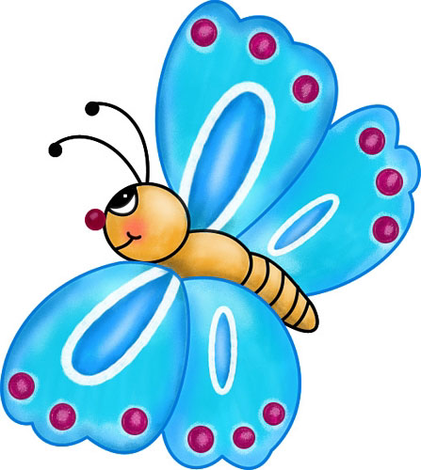  6:30-8:00 Arrivals  8:00-9:00 Outside play  9:00-9:15 Diapers/Restroom Break  9:15-9:30 AM Snack  9:30-10:40 Circle time, Table Toys, Music, Art Time  10:40-11:15 Child Directed Play and Centers  11:15-11:30 Wash up/ Restrooms  11:30-12:00 Lunch  12:00-12:30 Outdoor Play  12:30-12:45 Wash up/Diapers  12:45-3:00 Napping/Quiet Time  3:00-3:30 Restrooms/ Wash up and PM Snack  3:30-4:00 Teacher Directed Play  4:00-6:00 Outdoor Combined Play/Pick Ups | 6:30-8:00 Arrivals  8:00-9:00 Outside play  9:00-9:15 Restroom Break  9:15-9:30 AM Snack  9:30-10:15 Circle time  10:15-11:15 Teacher directed Activities, Art, Math, Science Table Time  11:15-11:45 Child Directed Play  11:45-12:00 Wash Up/Bathroom  12:00-12:30 Lunch  12:30-1:00 Outdoor Play/Bathroom  1:00-3:00 Napping/Quiet Time  3:00-3:30 Restrooms/ Wash up and PM Snack  3:30-4:00 Teacher Directed Play  4:00-6:00 Combined Play/Pick Ups | 6:30-8:00 Arrivals  8:00-9:00 Outside play  9:00-9:15 Restroom Break  9:15-9:30 Audiobooks/Journal  9:30-9:45 Snack  9:45-10:25 Circle time  10:25-11:15 Teacher directed Activities, Math, Science  11:15-11:40 Art, Music, One on One Time with Teacher  11:45-12:00 Free Play and Wash up  12:00-12:30 Lunch  12:30-1:00 Outdoor Play  1:00-3:00 Napping/Quiet Time  3:00-3:30 Restrooms and PM Snack  3:30-4:00 Student Directed Play/Recap of the Day  4:00-6:00 Combined Play/Pick Ups

